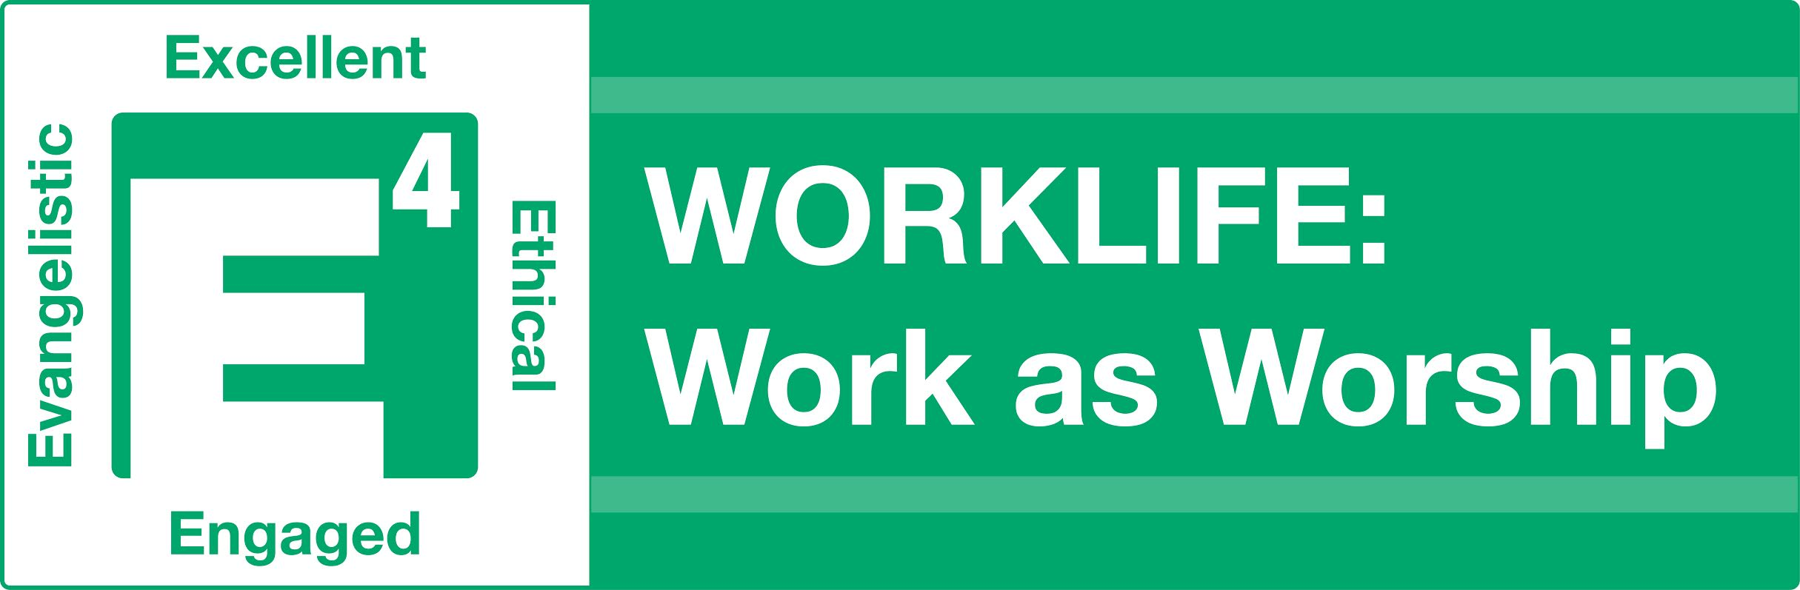TOOL KIT

Work as Worship Specific Resources
Short video clip on “Work as Worship” by RightNow Ministries https://www.youtube.com/watch?v=m06DYIAeCtU

Work Life and Calling email devotionals and blog/articles:
-TGIF Today God Is First by Os Hillyer at http://www.marketplaceleaders.org/
-BluePrint for Life: http://blueprintforlife.com/category/career/
-Theology of work article: http://www.intheworkplace.com/apps/articles/?columnid=1935&keywords=&byline=&topicid=136

Bible:
The Theology of Work Bible Commentary explores what the Bible says about faith and work, book by book through the Bible. https://www.theologyofwork.org/

Books:
-Every Good Endeavor: Connecting Your Work to God's Work by Timothy Keller
-Halftime: Moving from Success to Significance by Bob Buford
-Experiencing God: Knowing and Doing the Will of God by Henry & Richard Blackaby Bible study and other materials also available.

Worship God through the 4Es: Excellence, Ethical, Engaging and Evangelistic

EXCELLENT and ETHICAL
(Strong devotional, prayer and Bible study habits are critical to understanding and maintaining these behaviors)
Devotional Life and Prayer:
-7 Minutes with God pamphlet
-Tyranny of the Urgent pamphlet
-Lectio Divina Approach to Daily Devotionals: https://www.gotquestions.org/lectio-divina.html
-Short prayers for different parts of the job search: http://christiancareerjourney.com/pray.html

Methods & Approaches:
-Topical Memory System – Scripture memory course from the Navigators

Books:
-Knowing God by J. I. Packer
-Desiring God by John Piper
-A Praying Life by Paul Miller
-Too Busy Not to Pray by Bill Hybels
-The Life You’ve Always Wanted by John Ortberg
-Spiritual Disciplines for the Christian Life by Donald Whitney
-Know What You Believe by Paul Little
-Major Bible Themes by Lewis Chafer
-When People Are Big and God is Small Edward Welch

ENGAGING (Relating and Serving)
Spiritual Gifts Inventory based on Romans 12:
https://mintools.com/spiritual-gifts-test.htm

Service Projects:
- Your church, community service or nonprofit volunteer activities
- As you engage with your believing coworkers, encourage them to serve in tangible ways in their home church. You might also start to formally disciple some of these believers.
-Model service with others – Take fellow job seekers and future co-workers with you into service at the church or in the community so that you can model for them what it looks like.

Books:
-The Volunteer Revolution by Bill Hybels
-The Christian Employee by Robert Mattox
-The Treasure Principle by Randy Alcorn
-Total Forgiveness by R. T. Kendall
-Forgive! As the Lord Forgave You by Patrick Morison

EVANGELISTIC
Methods & Approaches:
-Bridge Illustration Training Video – https://vimeo.com/120370274 How to transition into and share the Bridge Illustration.
-BLESS approach to evangelism (Applies to the workplace, too) – https://www.evangelismcoach.org/2016/5-ways-bless-neighbor/
-Three Story Evangelism – http://www.gracewired.net/wp-content/uploads/2016/06/Three-Story-Evangelism-Bill-Muir.pdf
-Community Impact Evangelism Training Video – https://vimeo.com/164736649 (password: Chuck). Why we share the Gospel and specific approaches for interacting with Muslims.

-Spiritual Multiplication in the Real World – Study Guide, by Bob McNabb. Resource for a small group to increase evangelistic engagement.
-Discovery Bible Study Format – 6-8 questions you can ask of any passage in the Bible and use for either an evangelistic/seeker Bible study or to teach a very rudimentary approach to Bible reading/study to new believers.
-ExploreGod.com – Discussion format for the relevant questions of life and God.

Training Environments for Evangelism outside the workplace:
-Job Seekers Network intake process
-Hang out in Starbuck’s or some other similar place and start up conversations
-Short-term missions trips focused on evangelism
-Neighborhood parties or events
-Prison ministries
-Community Service / Volunteer outreach opportunities

Books:
-Spiritual Multiplication in the Real World – Study Guide by Bob McNabb
-God Space by Doug Pollock
-Gospel Fluency by Jeff Vanderstelt
-The Art of Neighboring by Pathak and Runyon
-The Compact Guide to World Religions by Halverson
Reproducing the 4 E’s in others as a Disciple Maker
Curricula and Approaches in Establishing Spiritual Basics:
-Navigators 2:7 Course
-One-to-One Discipling “Blue Book”
-Fully Formed Follower discipleship process developed at Hill Country Bible Church
-Born to Reproduce pamphlet by Dawson Trotman – Navigators
-Foundations (CRU) – new believer early follow up and discipleship to establish a person’s basic identity in Christ and to begin to follow Christ

Curricula and Approaches to Building Disciple Maker Leaders:
-Charting A Bold Course by Andrew Seidel
-Discipleship With A Purpose – Hill Country Bible Church developed course

Books:
-Lost Art of Disciple Making by LeRoy Eims
-Intentional Disciplemaking by Ron Bennett
-Master Plan of Evangelism by Robert Coleman
-Discipleshift by Jim Putman
-Spiritual Multiplication in the Real World by Bob McNabb
-Saturate by Jeff Vanderstelt
-The Measure of a Man by Gene Getz

